Lesson 06 EF Core Part 4 & Simple Web Reporting

1. If you are yet to complete project setup, please perform project setup following instructions in **C286 L06 Project Setup Guide.docx** first.
2. Open **Task List** window from the menu **VIEW**, **Task List**. Use the **Filter** function in the Project heading to display only the Tasks for Lesson06.

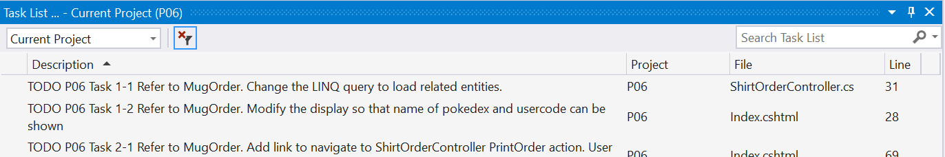

# Solving the Problem

1. You are suggested to complete the solution in the following order:
   * + 1. Implement **Feature 1 & 2** by following **Tasks 1 and 2**:
          1. **Tasks 1-2 and 2-1** are in **Views/ShirtOrder/Index.cshtml**
       2. Implement all required components for **Feature 3**, the Cake Order features.
          1. The image cake.png in **images** folder can be used to display the cake sample:

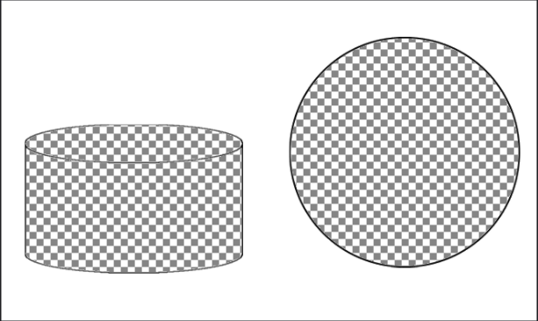

* + - * 1. Following is a strawberry cake order with greeting text “Happy Birthday”:

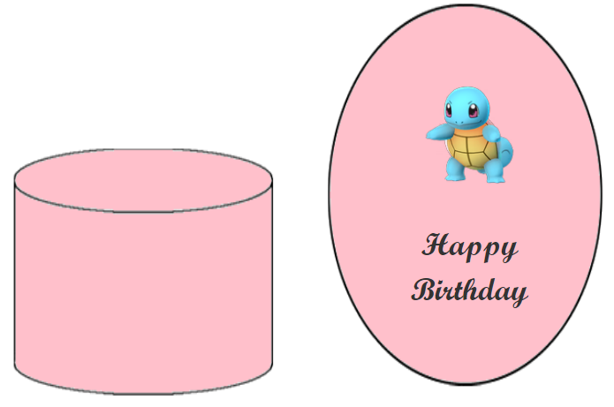

# Testing your App

Provide test cases here and screen shots to demonstrate that your web app is functioning well.

*— End of Worksheet —*